1. Program name = Business

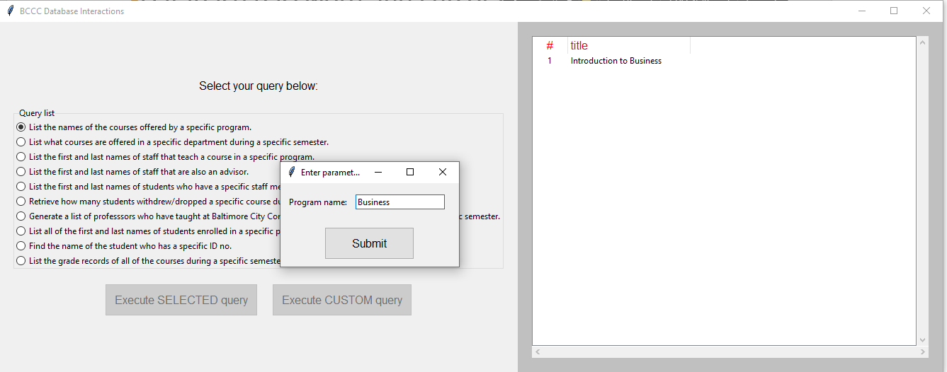

1. Department name = Business, Section semester = Fall, Section year = 2020

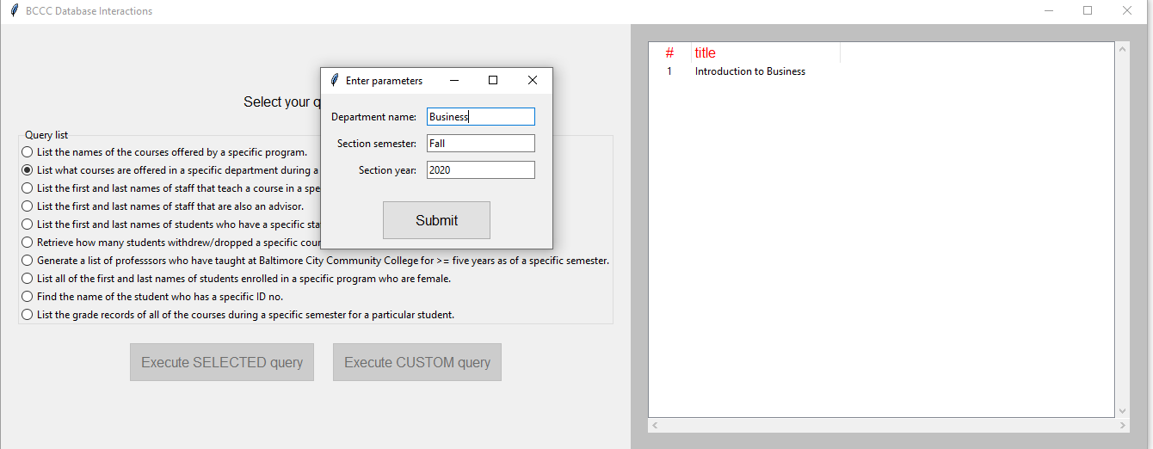

1. Program name = Business

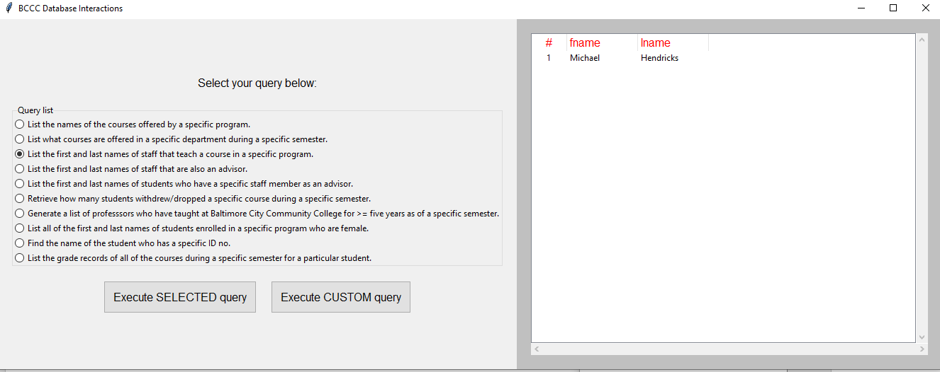

1. No parameters

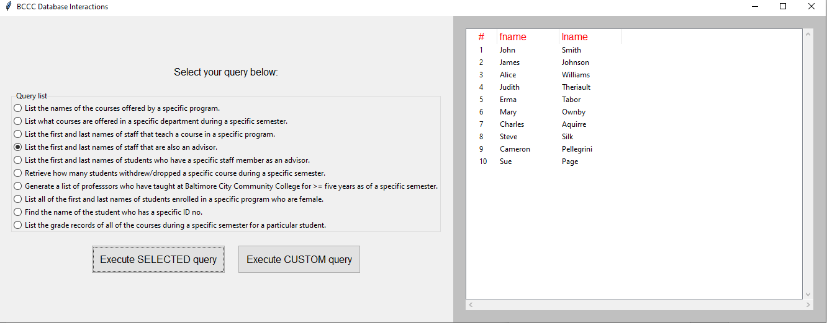

1. Advisor fname = Steve, advisor lname =Silk

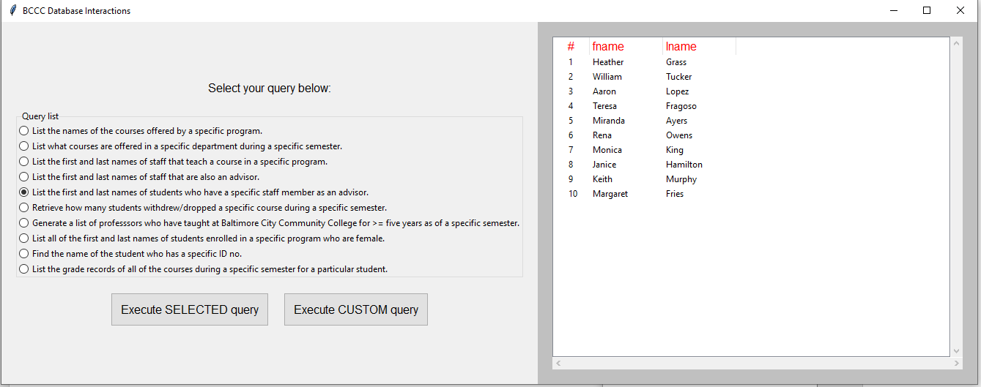

1. Student section status = dropped, Course code = ARTS-101, Section semester = Fall, Section year = 2020

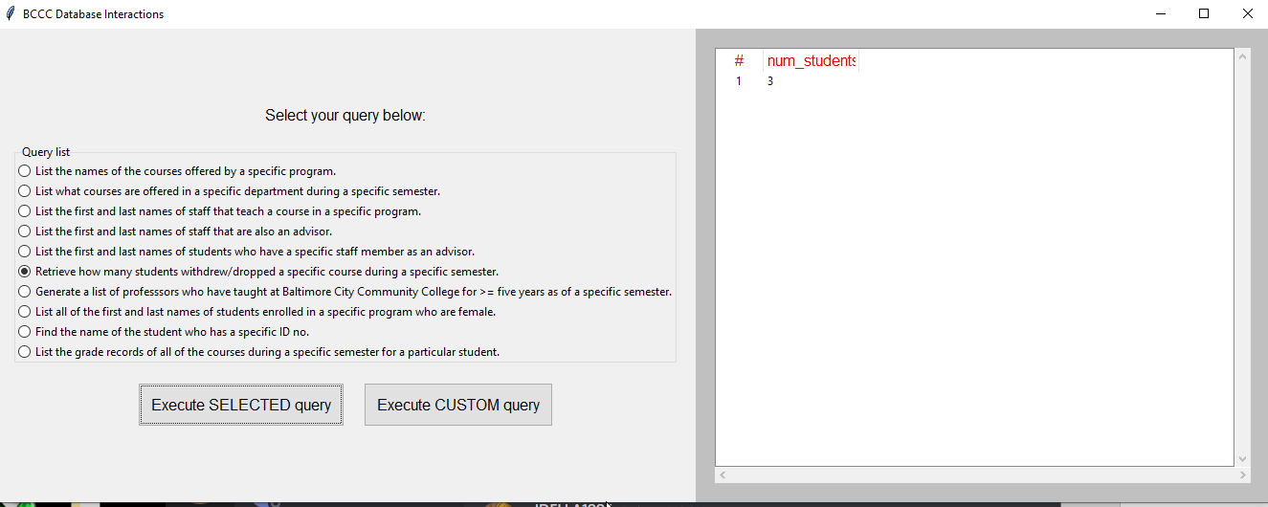

1. Section semester = Fall, Section year = 2020

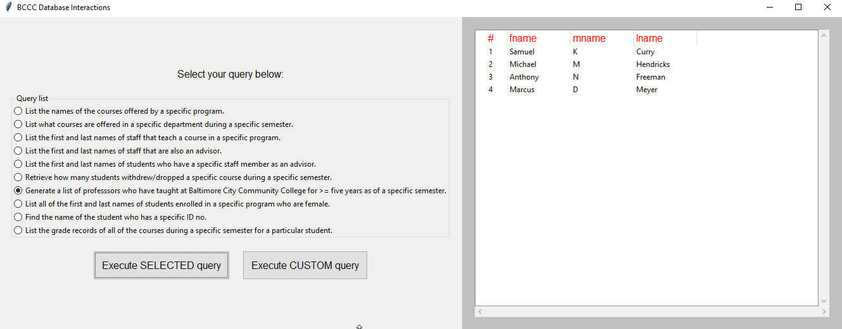

1. Program name = Business

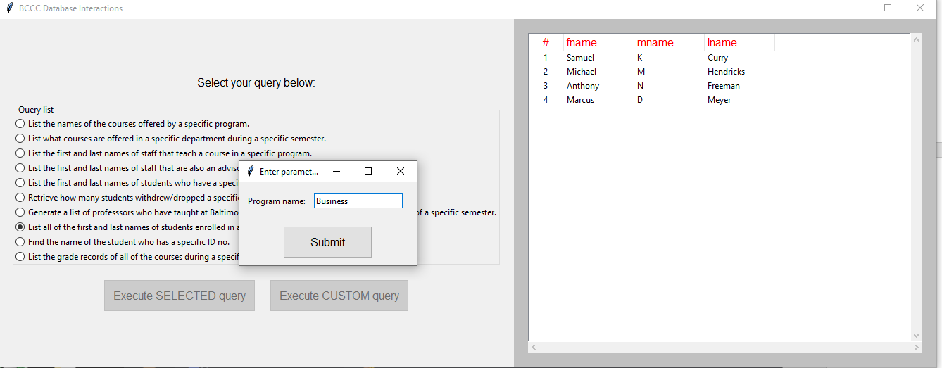

1. Program name = Business

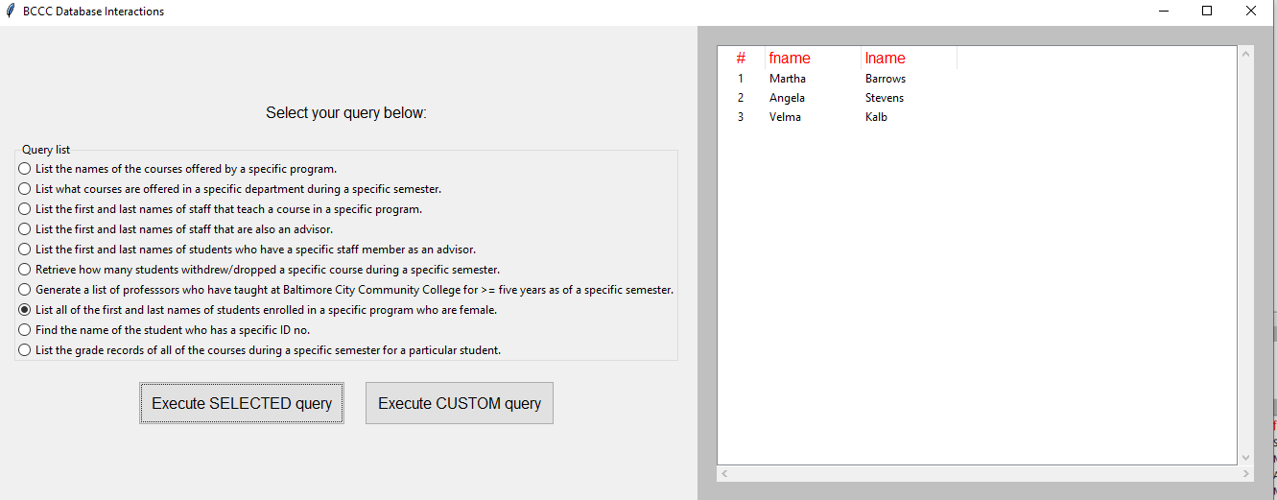

1. Student ID = 1

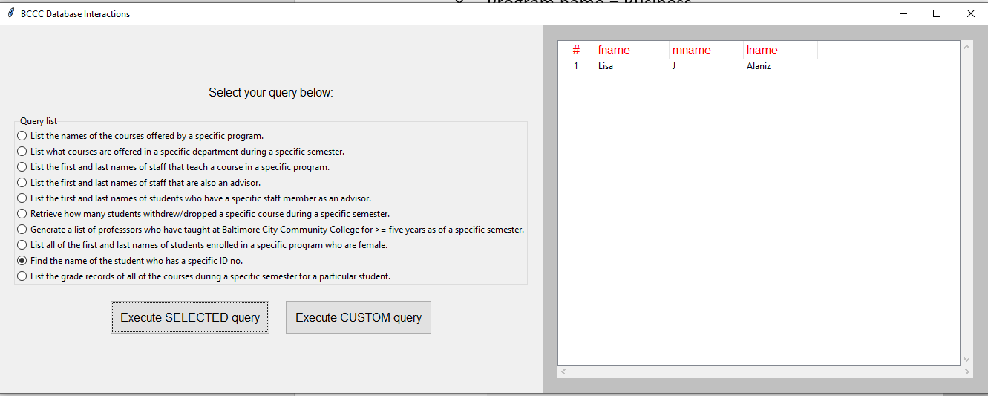

1. Example custom query; SELECT * FROM cosc457.Id_christian